For students signing into Teams for the first time:
- Sign into your Office 365 account. The link (Office 365 Home) can be found at the top of the school district site at https://www.sd58.bc.ca/ or you can go to office.com
Your username is your first initial and your last name followed by the last three digits of your student number followed by @sd58.bc.ca
Ex. Jane Doe has student number 1234567
Her username is jdoe567@sd58.bc.ca
Your password is sd and your full student number. Jane’s would be sd1234567

NOTE: if you have multiple family members signing into Office 365 on the same computer, you may want to use different browsers (ex. one on Edge, another on Chrome) and make sure that each user signs out when they are done. Alternatively, you can allow them to have different accounts on the computer to avoid sign-in issues. You must set this up in your Settings menu under Accounts.

- Once signed in, use the waffle in the top left corner, to find the Teams App:
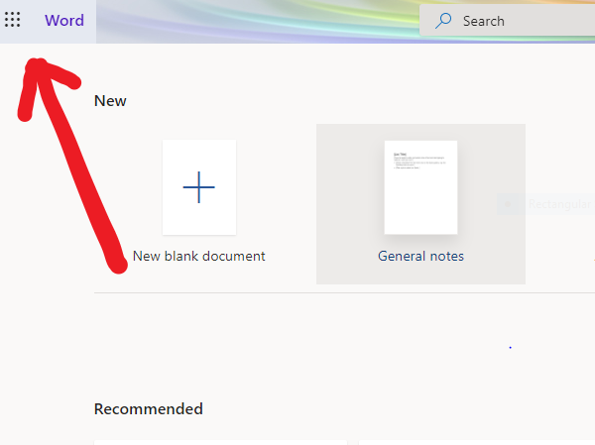

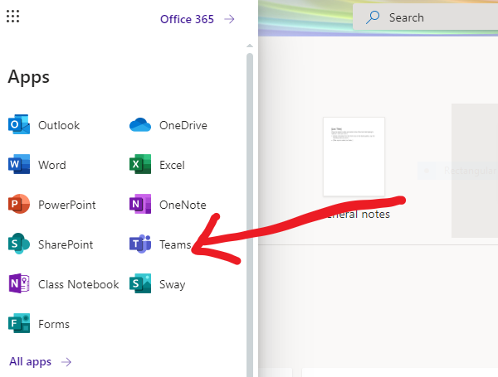

- Once in teams, you can use the sidebar to navigate through activities, chats and different teams (some students may have more than one depending on their teachers).
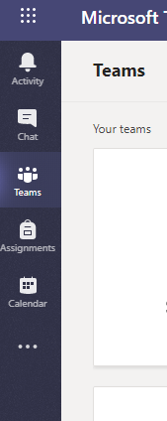

- To select different apps, such as zoom (for meetings), select the three dots at the bottom of the sidebar.
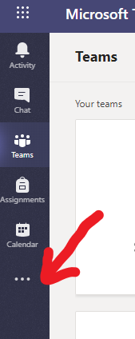

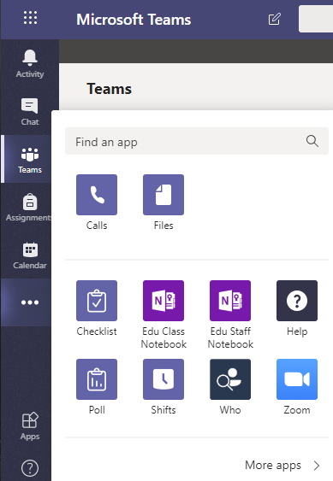
(If zoom doesn’t show up on your menu you can search for it by typing zoom where it says “find an app.” You may need to “add” the app if it isn’t already in your list)

- When in a team, you can use the menu options at the top, to navigate through the shared resources and apps:
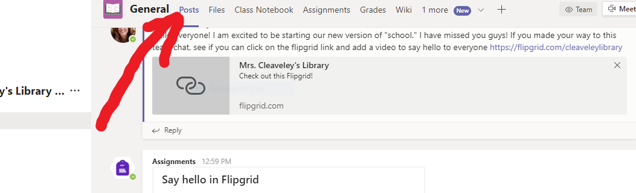
- Now that you are in, take some time to look around and get familiar with Teams. You can use the chat feature to have conversations with your whole group or individuals. You can have live video conferences, using Zoom, and you can keep track of meetings and events on your calendar. Don’t forget to check your activity for new conversations or assignments from your teacher. Good luck and have fun!

