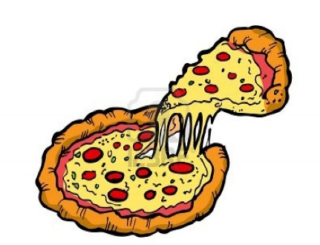
PIZZA WEDNESDAYS
$2.00 per slice (Pizza from Yaki Joe’s)

Please return this order form with payment by Monday, January 6th. We are unable to accept late orders. Please use a separate order form for each child.

Name: _______________________ Teacher: ____________________
 | Quantity of each | Total
Wednesday, Jan 8 | Cheese _______  Pepperoni _______  Ham & Pineapple _______
Wednesday, Jan 15 | Cheese _______  Pepperoni _______  Ham & Pineapple _______
Wednesday, Jan 22 | Cheese _______  Pepperoni _______  Ham & Pineapple _______
Wednesday, Jan 29 | Cheese _______  Pepperoni _______  Ham & Pineapple _______
Total enclosed
Any excess funds will go to PAC to benefit the Grade 7 Year End Event!

